GUI Programming Task 1 (A, B, C) and Task 3

Ivan White

2019

# A.

I chose to use Visual Studio as my IDE for the component application because it is very stable and will allow me to build a native Windows Forms application using C#.

I used a relational SQL database for the application because it is reliable and uses tables which are well suited to the needs of the application. I used Microsoft SQL Server to create the database.

# B.

## Database Tables

The database consists of two tables. There is no relationship between them.

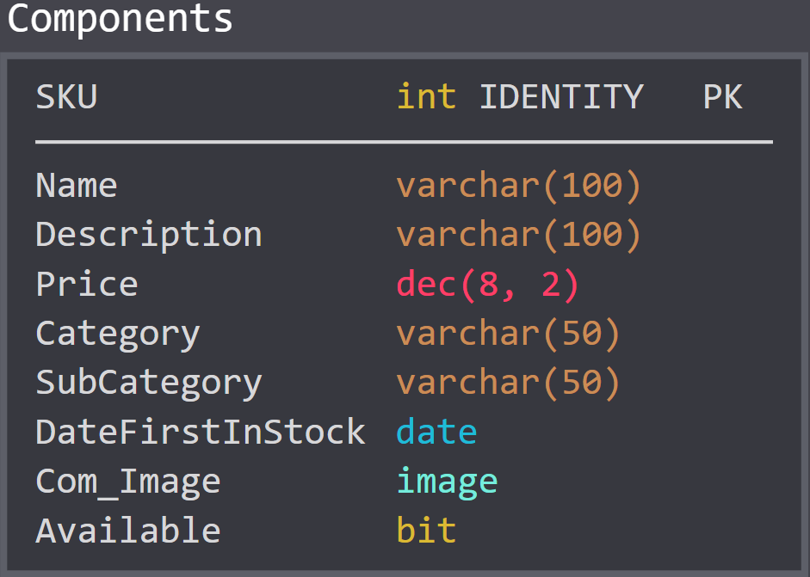

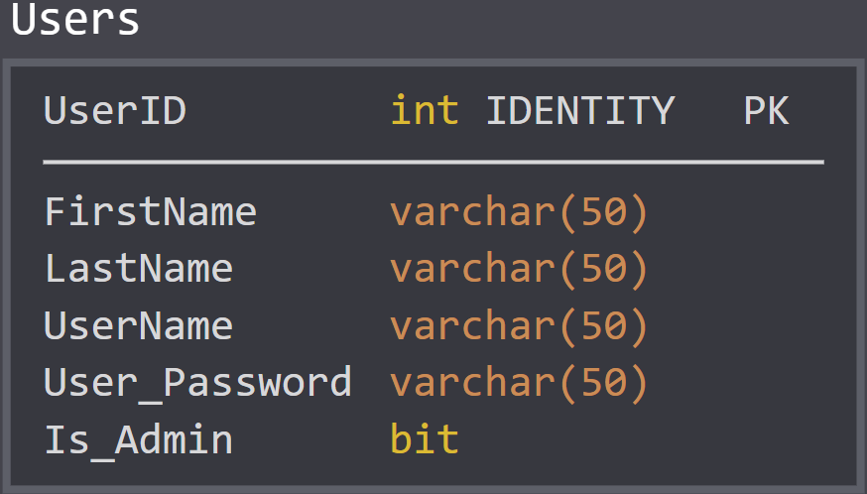

# C.

I decided to use the diagrams provided in Appendix B as a template for my own design to help keep things simple. I made a few changes to the design as I saw fit while working on the application. These changes included the following:

* Removing the Edit and Search buttons from the menu bar because they were duplicates of the buttons on the Main Window
* Removing the Upload Image button from the Main Window and replacing it with an “Upload Image Here” on the image box when the edit button is clicked
* Adjusting the layout of the Search Window

The add, edit, and delete buttons on the main menu will only be available for admin users, with search being the only option for standard users.

## System Structure

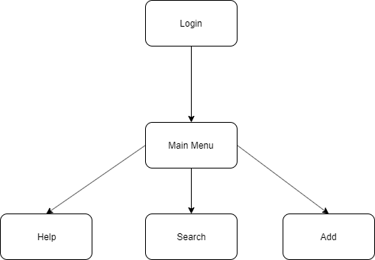

## GUI Wireframes

### Login Screen

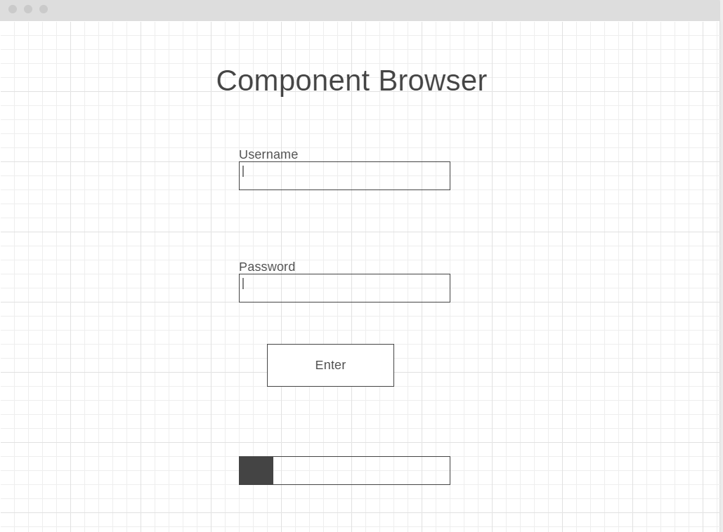

### Main Menu/Component View Screen

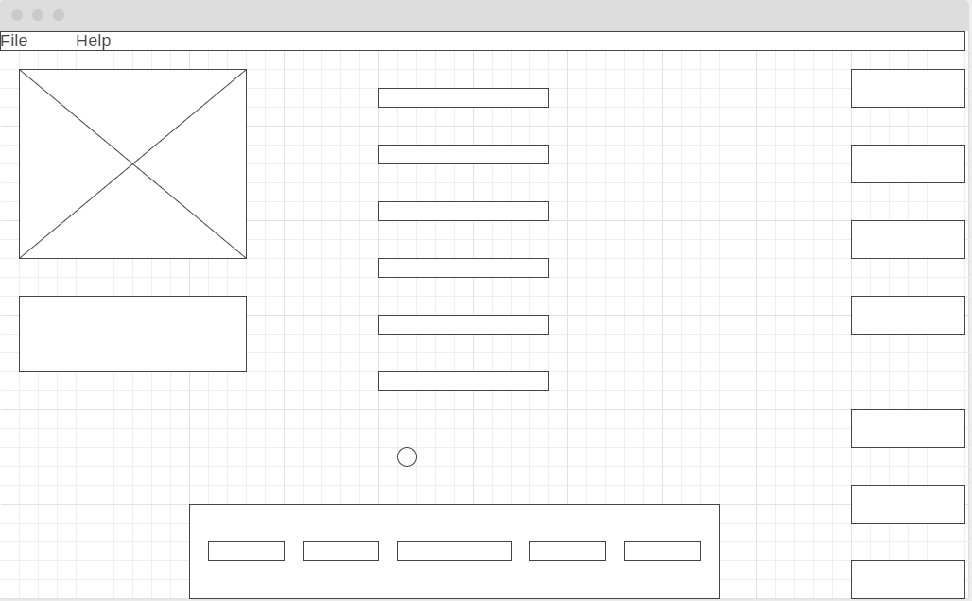

### Search Screen

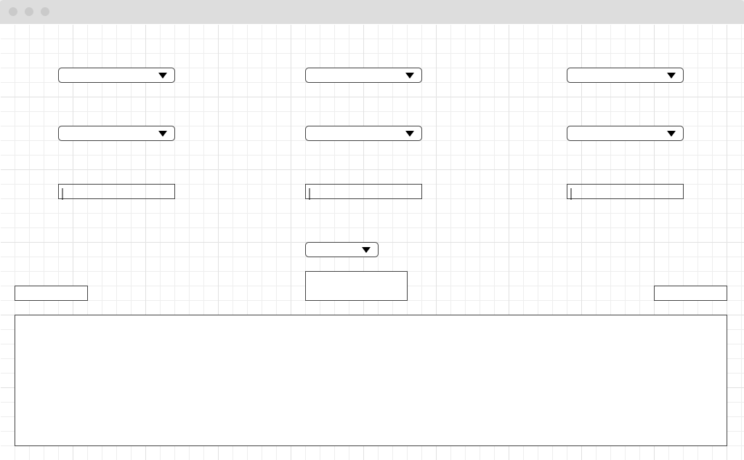

### Add Screen

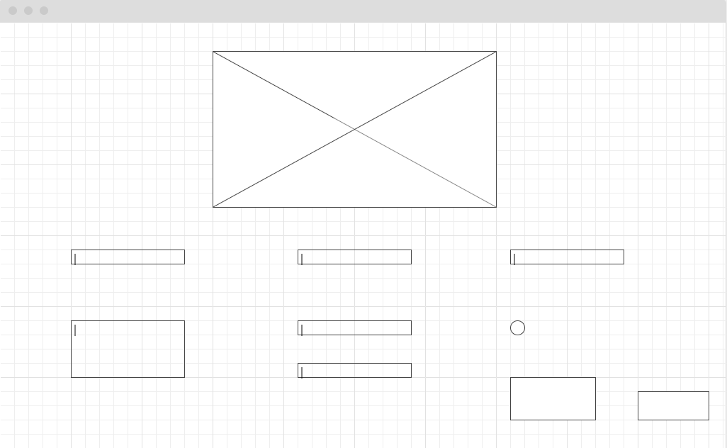

## Screenshots

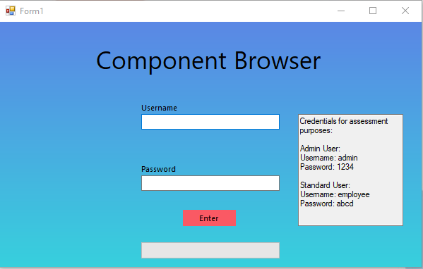

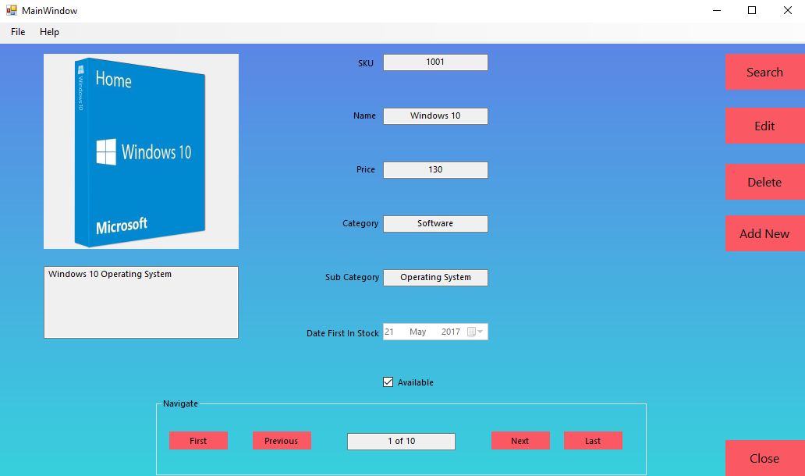

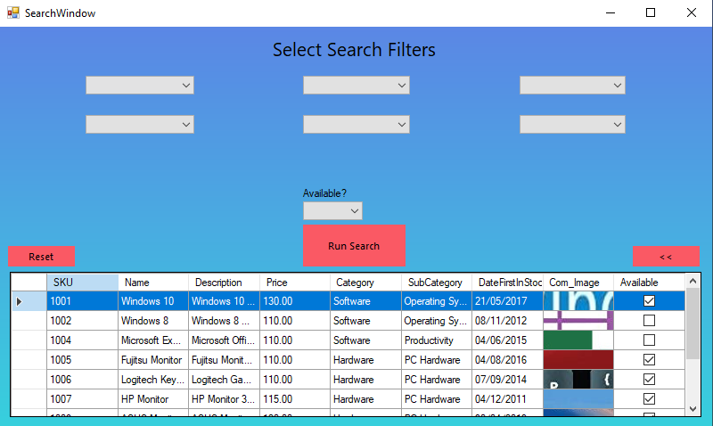

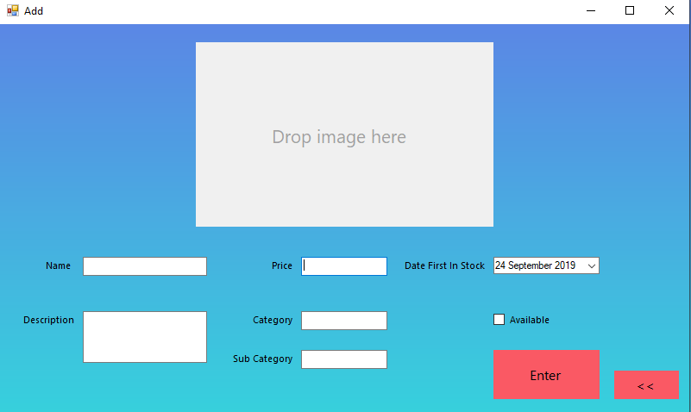

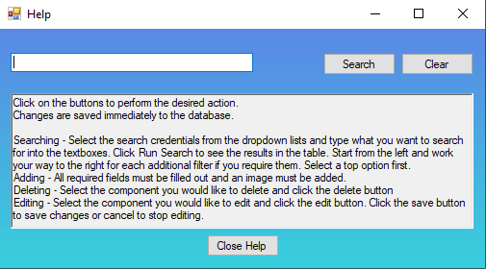

# Deployment Plan

This application should work on any modern Windows PC which has the .NET Framework installed.

SQL Server should be installed on the PC. SQL Server 2017 Express is a free edition of SQL Server and is recommended.

Unzip the folder and place it in the desired folder on your PC. This folder must remain in this location after the application is installed, otherwise you will encounter an error.

To install the application simply double click on the file “GUI Component Application” in the root folder and the setup wizard will start. Follow the instructions to complete the installation. The application will start automatically after setup is complete. Please allow upto 30 seconds for application to start after installation.

Double clicking on the same file “GUI Component Application” will start running the application after it has been installed and run for the first time.